WIRELESS SMART AGRICULTURE SYSTEM USING XBEE MODULE

ABSTRACT

Agriculture sector is one of the most important sectors in each country. People require food to be able to carry out in their daily activities. Agriculture sector have been improved from the traditional form to the modern form. Technology has been implemented in the sector to maximize the harvest due to increase in population. Most of the crops are planted on a large scale and this makes it difficult for the farmer to monitor the situation of the crops. Wireless devices have been created and implanted on the field to solve this issue. Xbee module is one of the wireless devices, it uses Radio waves to transmit data serially. The Xbee transmitter is placed on the farm and the farmer is able to access data from the Xbee receiver. The system will also have sensors that help in gathering field’s data. The system will have a soil moisture sensor and a pH sensor, which monitors the condition of the soil. A temperature and humidity sensor to monitor the weather. This system will maximize production on this field of agriculture.

Keywords— Android studio, Xbee module, Atmega328P, pH sensor, soil moisture sensor, temperature and humidity sensor, pump.

# **Introduction**

Xbee devices are one of the RF modules. They use radio waves for wireless data transmission. When they are indoors they have a data transmission range of 60 to 90 meters. When used outside with a clear line of sight they have a data transmission range of 1.2 to 3.2 kilometers depending on the version of Xbee device the user is using. Xbee devices have a separate transmitter and a receiver module. They transmit data faster and they are compact, minimizing the need for constant maintenance. In addition the module requires very less power for operation, it requires a power supply of around 2.1 to 3.6, which can be supplied easily by the help of rechargeable lithium cells. The devices have two communication protocols which can help with the connection between the embedded devices, it has UART and SPI [8]. Xbee devices also come at an affordable price. Xbee devices are the best choice when selecting a wireless device to implement when constructing a smart system. One of the robust Xbee device called Xbee pro 900 has an operating range of about 24 kilometers!

# **Ease of Use**

Xbee devices are easier to operate with. Since the device has a separate receiver and a transmitter. Xbee devices are compatible with Atmega chips such as Atmega328P and Atmega32. The Atmega chips can be used to host data transmission between the Xbee devices. Xbee devices can also be used as standalone devices [8], [7].

# **HARDWARE**

1. Atmega328P chip

Atmega328P will be used in the smart agriculture system as a host device. The chip will be interfaced with the Xbee devices and sensors. In this design two Atmega328P chips will be used, one chip will be placed in the field. It will be interfaced with an Xbee device and data collection sensor and a pump. The other chip will be placed at the farm’s control room, where it will be used to host data transmitted from the farm and it will also be used to transmit commands to the pump in the field. The chip will be programmed [3].

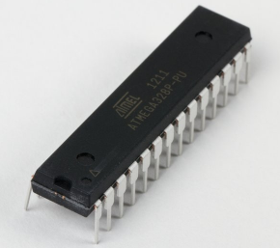

Atmeag328P chip

1. Xbee device

The wireless device has two modules, a transmitter and a receiver. It can transmit data at a frequency of 2.4 GHz or 900 MHz [6], [8].

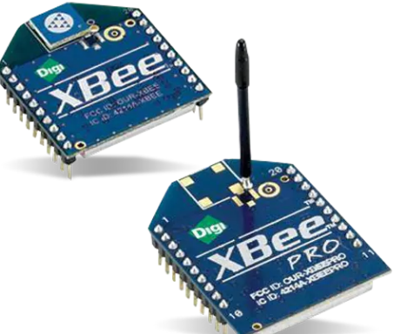

Xbee devices

1. Soil moisture content sensor

This sensor measures the water level in the soil. It can transmit data via analog pins or digital pins [13].

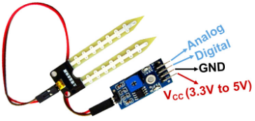

Water level sensor

1. pH sensor

This sensor measures the pH level of the soil [11], [12].

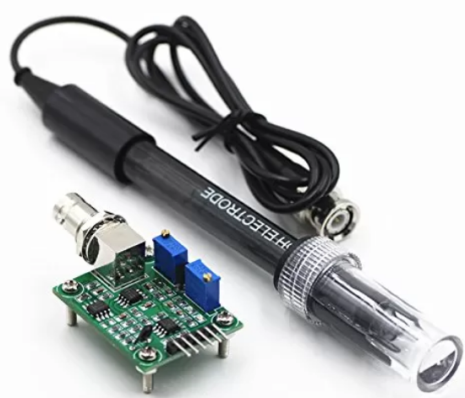

pH sensor

1. temperature and humidity sensor

DHT11 is preferred for this operation because it measures both temperature and humidity [10].

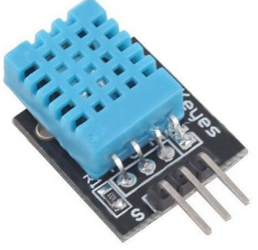

Temperature and humidity sensor

1. Pump

The pump will be used in this case to water the plants. It will receive commands from the control room.

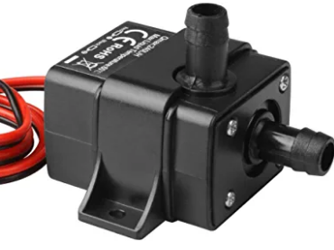

Pump

# **METHODOLOGY**

#### **Proposed system workability**

The proposed wireless smart agriculture system will have the following components mentioned above. The system will have two control units. One control unit will have one Atmega328P which will be connected to Xbee receiver and Xbee transmitter, all the above-mentioned sensors and a pump. The above mentioned will constantly monitor fields data, store the data temporarily on the SRAM. Then the data will be transmitted by the help of the Xbee transmitter to the other control unit, where the farmer would have set up the control room.

The control room would have the other Atmega328P which will have both Xbee transmitter and receiver. Data sent from the field will be received by the Xbee receiver in the control room. The farmer will have user interface applications that helps in interpretation of data received. Through the user applications the farmer can send commands to the pumps to either water the plants or apply chemicals to the plants through the Xbee transmitter in the control room.

The system will have two pumps, one pump will be connected to a water tank for watering the plants, and the other will be connected to pH solution tanks for supplying the solution in the field

The pump can also operate automatically. This provides an advantage especially when the farmer is monitoring the user interface applications. The pumps will operate under the following conditions [1], [2], [4]:

1. When the moisture level is below threshold, the water pump will be started to help irrigate the crops.
2. When the water level is above threshold, the pumps will be stopped. Unless the farmer uses the user interface applications to start the pumps.
3. When the soil pH is above threshold, the neutralizer solution pump is activated.
4. When the soil pH is below threshold, a lime-based compound is pumped.

#### **Smart agriculture system block diagrams**

1. Field’s control system
2. Control room’s control unit block diagram

#### **Proposed system flowchart**

#### **User interface application**

The user interface application will be of help when the farmer want to visualize some data about the field and the weather. The user interface application will display data such as soil water level, soil pH content, temperature values, and humidity data. Soil data will be visualize in form of percentage and the weather data will be visualized in form of a line graph.

The user interface application will be designed using Android Studio application. Android studio application is an Integrated Development Environment (IDE) used for designing Android Applications [15].

# **MODELLING**

Circuit modelling was done in Proteus version 8.6. Proteus version 8.6 is a software used to design Printed Circuit boards. Design of the PCB (Printed Circuit Board) was done where all the components were interfaced correctly. The software can also provide virtual simulation of the circuits [1].

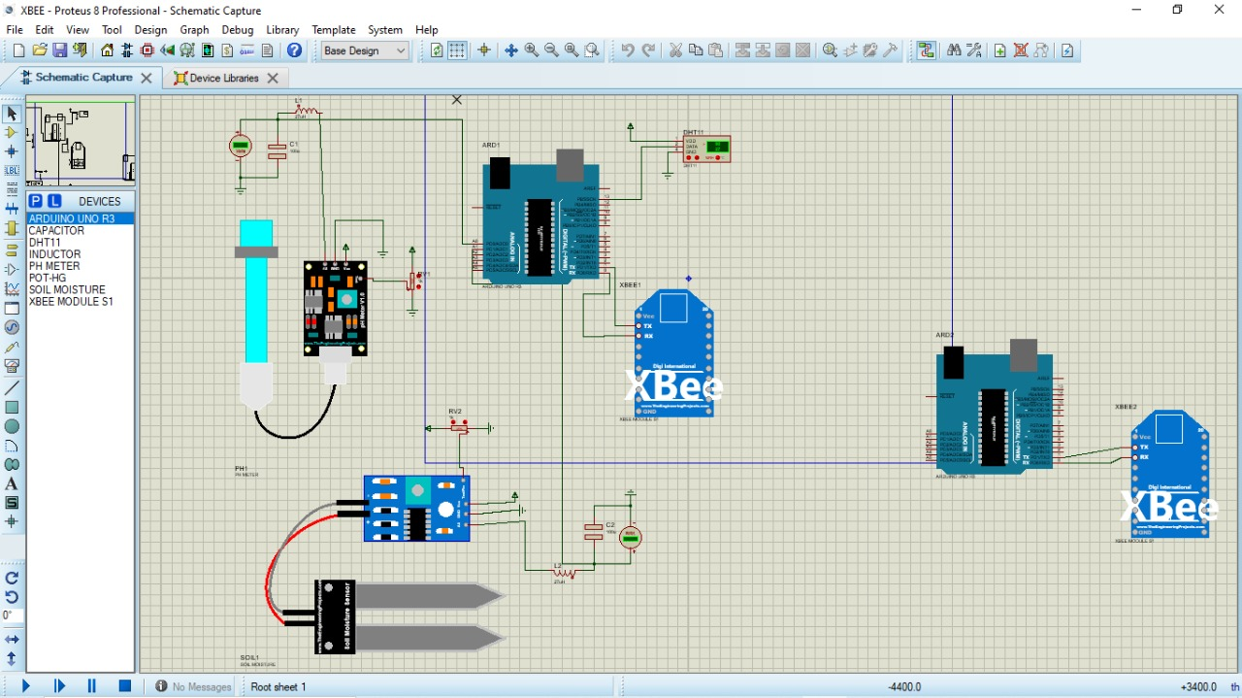

Proteus circuit diagram

**System’s communication protocol**

Data is transmitted wirelessly by use of radio waves. Data is sent from one control unit RF device is sent in the form of a waveform. The RF modules are being set to a certain frequency, which they operate in. Data is transmitted wirelessly to the receiver which is tuned to the same frequency as the other one controller [5]. Xbee devices can operate in 11 to 26 channels [8].

**Control unit communication protocol**

The communication protocol between the Atmega328P and the Xbee device is UART (Universal Asynchronous Receiver/Transmitter). UART transmission can be either serial or parallel. The communication protocol only requires two wires for connection. The communication is done via Tx and Rx port. [9], [8]

# **RESULTS AND DISCUSSION**

In this chapter we will speculate on how the system should respond on the real world interface. The water level sensor has a probe, the probe will be stuck on the ground. The water level sensor will monitor the water level in the soil and send its data to the Atmega328P chip. The Atmega328P will have a set of conditions to operate the Pump under the set conditions. The data collected will be transmitted by the help of the Xbee device to its receiver on the other end. The data sent will be visualized as a percentage.

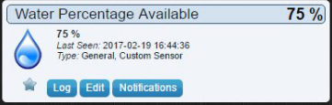

Water level percentage

The same thing will happen with the pH sensor. It will collect the pH of the soil and send it data to the Atmega328P chip. The pump will be actuated according to the set of conditions set. At the same time the data will be transmitted to the other controller with the help of the Xbee device. Data will be displayed as a percentage on the user interface application

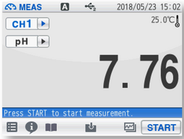

pH level percentage display

Temperature and humidity sensor will constantly monitor temperature and humidity values. Data will be transmitted to the Atmega328P chip and data is transmitted to the control room. In the user interface application the transmitted data will be received and decoded and displayed as a graph.

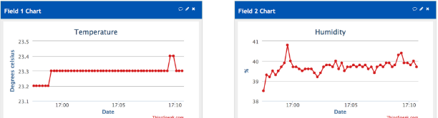

Temperature and humidity graph display

The user interface application will have control pushbutton, interfaced in it. The pushbutton will be used to control the pumps manually according to the farmer’s preferences.

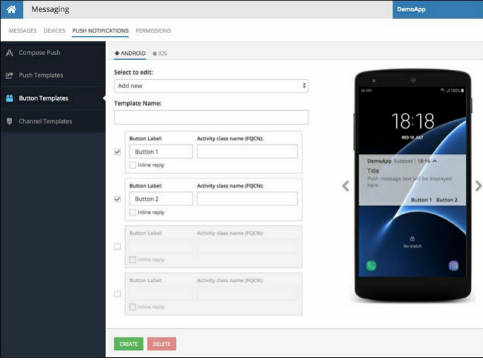

Android Studio Pushbutton interface

# **CONCLUSION**

The proposed wireless agriculture smart system prototype has been discussed in detail. The system is analyzed to be robust and it is also cost effective. Data transmission used in this article is considered suitable since Xbee devices have been analyzed to have a wider range of operation than other IoT wireless devices. Therefore the system can be implemented in real world. The system can be very suitable at large plantations, it can minimize human efforts and ensure maximum crop production. Efforts can be made so as to ensure the system is more compact and can function in the real world.

# **VIII.ACKNOWLEDGEMENT**

Special regards to our Professor for giving us insight about embedded system workability, sensor interfacing and both embedded system programming. Special regards also to Digi Xbee Company for making such an amazing RF module.

**REFERENCES**

[1]. Adetiba, E., Olumba, C.F., Ifijeh, A.H., Noma-Osaghae, E., Adetiba, J.N., Ameh, J. and Matthews, O.A., 2021. Internet of Things and Farm Management Information System for Precision Agriculture: A Proof of Concept Circuit, Simulation and Web App.

[2]. Kumar, K.A. and Aju, D., 2020. An Internet of Thing based Agribot (IOT-Agribot) for precision agriculture and farm monitoring. Int. J. Educ. Manag. Eng, 10(4), pp.33-39.

[3]. KC, M.M. and IM, M.T.A., IOT BASED AGRICULTURE MONITORING SYSTEM.

[4]. Ghodake, M.Y.S., Parlikar, P.S., More, B.S. and Kulkarni, B.S., WIRELESS INDUSTRIAL AND AGRICULTURAL MACHINE CONTROL USING LO-RA.

[5]. Rehman, M.U., Safdar, G.A. and Chaudhry, M.A.R. eds., 2022. Interference Mitigation in Device-to-device Communications. John Wiley & Sons.

[6]. Calvo, I., Gil-García, J.M., Villar, E., Fernández, A., Velasco, J., Barambones, O., Napole, C. and Fernández-Bustamante, P., 2021. Design and performance of a xbee 900 mhz acquisition system aimed at industrial applications. Applied Sciences, 11(17), p.8174.

[7]. Desnanjaya, I.G.M.N., Hartawan, I.N.B., Parwita, W.G.S. and Iswara, I.B.A.I., 2020. Performance Analysis of Data Transmission on a Wireless Sensor Network Using the XBee Pro Series 2B RF Module. IJEIS (Indonesian J. Electron. Instrum. Syst, 10(2), p.211.

[8]. XBEE, D., 2020. S2C 802.15. 4 RF MODULES Datasheet.

[9]. Dawoud, D.S. and Dawoud, P., 2020. Serial Communication Protocols and Standards RS232/485, UART/USART, SPI, USB, INSTEON, Wi-Fi and WiMAX (pp. i-xl). River Publishers.

[10]. Shrestha, R., 2019. Study and Control of DHT11 Using Atmega328P Microcontroller. International Journal of Scientific & Engineering Research, 10(4,518-521).

[11]. Young, S.J. and Tang, W.L., 2019. Wireless zinc oxide based pH sensor system. Journal of the Electrochemical Society, 166(9), p.B3047.

[12]. Irawan, Y., Febriani, A., Wahyuni, R. and Devis, Y., 2021. Water quality measurement and filtering tools using Arduino Uno, PH sensor and TDS meter sensor. Journal of Robotics and Control (JRC), 2(5), pp.357-362.

[13]. Akinwole, O.O., 2020. Design, simulation and implementation of an Arduino microcontroller based automatic water level controller with I2C LCD display. International Journal of Advances in Applied Sciences (IJAAS), 9(2), pp.77-84.

[14]. Benyezza, H., Bouhedda, M., Djellout, K. and Saidi, A., 2018, November. Smart irrigation system based ThingSpeak and Arduino. In 2018 International conference on applied smart systems (ICASS) (pp. 1-4). IEEE.

[15]. Hagos, T., 2019. Android Studio IDE Quick Reference: A Pocket Guide to Android Studio Development. Apress.